

**UCS1711 - MOBILE APPLICATION DEVELOPMENT LAB**

**Assignment 6**

Name: Jayannthan P T

Dept: CSE ‘A’

Roll No.: 205001049

Finding geo coordinates of a location and Reverse Geocoding

a) Develop an android application to find the latitude and longitude of current location and the selected location in a google map using anyone of the below options:

1) Location Manager

2) Network Provider

3) GPS Provider

b) Also perform Reverse Geocoding i.e., given a latitude and longitude of a location, app should display the location name or given a location name it should display the latitude and longitude of that place.

**Ex. No:6**

**Title of the Program:** Create an Android mobile application which finds geo coordinates of a location and Reverse Geocoding.

**Objective:**

The objective of the Location Finder Android App project is to develop an application that enables users to find location coordinates (latitude and longitude) based on a provided address. The app utilizes the device's GPS functionality and geocoding to convert an address into corresponding geographical coordinates.

**Algorithm:**

1. Request runtime permission for accessing fine location to enable GPS functionality.
2. Set up a button click listener to trigger the location-finding process.
3. Create a LocationManager instance and request location updates from the GPS provider.
4. Implement the LocationListener interface to receive updates when the device's location changes.
5. Upon receiving a location update, retrieve latitude and longitude values.
6. Use Geocoder to convert a user-provided address (from an EditText) into location coordinates.
7. Display the latitude, longitude, and address details on the UI.

**Features used:**

1. Runtime permission handling for accessing fine location.
2. Utilization of LocationManager for obtaining location updates.
3. Implementation of LocationListener to respond to location changes.
4. Geocoding with Geocoder to convert an address into coordinates.
5. UI components such as TextViews and EditText for displaying and inputting information.
6. Button click handling to initiate the location-finding process.

**Source code:**

* MainActivity.java

package com.example.exercise5;

import androidx.annotation.NonNull;

import androidx.appcompat.app.AppCompatActivity;

import androidx.core.app.ActivityCompat;

import androidx.core.content.ContextCompat;

import android.Manifest;

import android.annotation.SuppressLint;

import android.content.pm.PackageManager;

import android.location.Address;

import android.location.Geocoder;

import android.location.Location;

import android.location.LocationListener;

import android.location.LocationManager;

import android.os.Bundle;

import android.view.View;

import android.widget.Button;

import android.widget.TextView;

import java.util.List;

import java.util.Locale;

public class MainActivity extends AppCompatActivity implements LocationListener {

    @Override

    protected void onCreate(Bundle savedInstanceState) {

        super.onCreate(savedInstanceState);

        setContentView(R.layout.activity_main);

        if (ContextCompat.checkSelfPermission(MainActivity.this,

                Manifest.permission.ACCESS_FINE_LOCATION) != PackageManager.PERMISSION_GRANTED) {

            ActivityCompat.requestPermissions(MainActivity.this, new String[] {

                    Manifest.permission.ACCESS_FINE_LOCATION

            }, 100);

        }

        ;

        Button find = (Button) findViewById(R.id.find);

        find.setOnClickListener(new View.OnClickListener() {

            @Override

            public void onClick(View view) {

                findLocation();

            }

        });

    }

    @SuppressLint("MissingPermission")

    private void findLocation() {

        try {

            LocationManager locationManager = (LocationManager) this.getSystemService(LOCATION_SERVICE);

            locationManager.requestLocationUpdates(LocationManager.GPS_PROVIDER,

                    5000, 5, MainActivity.this);

        } catch (Exception e) {

            e.printStackTrace();

        }

    }

    @Override

    public void onLocationChanged(@NonNull Location location) {

        TextView latitude = (TextView) findViewById(R.id.latitude);

        TextView longitude = (TextView) findViewById(R.id.longitude);

        String get_latitude = latitude.getText().toString();

        latitude.setText(get_latitude + location.getLatitude());

        String get_longitude = longitude.getText().toString();

        longitude.setText(get_longitude + location.getLongitude());

        try {

            Geocoder geocoder = new Geocoder(MainActivity.this, Locale.getDefault());

            List<Address> addresses = geocoder.getFromLocation(location.getLatitude(), location.getLongitude(), 1);

            String address = addresses.get(0).getAddressLine(0);

            TextView current_address = (TextView) findViewById(R.id.address);

            current_address.setText(address);

        } catch (Exception e) {

            e.printStackTrace();

        }

    }

}

* activity_main.xml

<?xml version="1.0" encoding="utf-8"?>

<LinearLayout xmlns:android="http://schemas.android.com/apk/res/android"

    xmlns:app="http://schemas.android.com/apk/res-auto"

    xmlns:tools="http://schemas.android.com/tools" android:layout_width="match_parent" android:layout_height="match_parent" android:orientation="vertical" tools:context=".MainActivity">

    <TextView android:layout_width="wrap_content" android:layout_height="wrap_content" android:layout_margin="40dp" android:gravity="center|center_horizontal|center_vertical" android:layout_gravity="center|center_horizontal|center_vertical" android:text="LOCATION FINDER" android:textSize="48dp" android:typeface="monospace" android:textStyle="bold" android:textColor="#000000"/>

    <TextView android:id="@+id/latitude" android:layout_width="wrap_content" android:layout_height="50dp" android:layout_marginStart="40dp" android:layout_marginTop="50dp" android:gravity="left" android:text="Latitude: " android:textSize="32dp" android:typeface="monospace" android:textStyle="bold" android:textColor="#55bb22"/>

    <TextView android:id="@+id/longitude" android:layout_width="wrap_content" android:layout_height="50dp" android:layout_marginStart="40dp" android:layout_marginTop="30dp" android:gravity="left" android:text="Longitude: " android:textSize="32dp" android:typeface="monospace" android:textStyle="bold" android:textColor="#55bb22"/>

    <TextView android:id="@+id/address" android:layout_width="wrap_content" android:layout_height="50dp" android:layout_marginStart="40dp" android:layout_marginTop="30dp" android:gravity="left" android:text="Address: " android:textSize="32dp" android:typeface="monospace" android:textStyle="bold" android:textColor="#55bb22"/>

    <Button android:id="@+id/find" android:layout_width="wrap_content" android:layout_height="wrap_content" android:layout_gravity="center" android:layout_marginTop="100dp" android:gravity="center" android:text="Find" android:textColor="#55bb22" android:textSize="32dp" android:textStyle="bold" android:typeface="monospace" android:backgroundTint="#000000"/>

</LinearLayout>

**Output:**

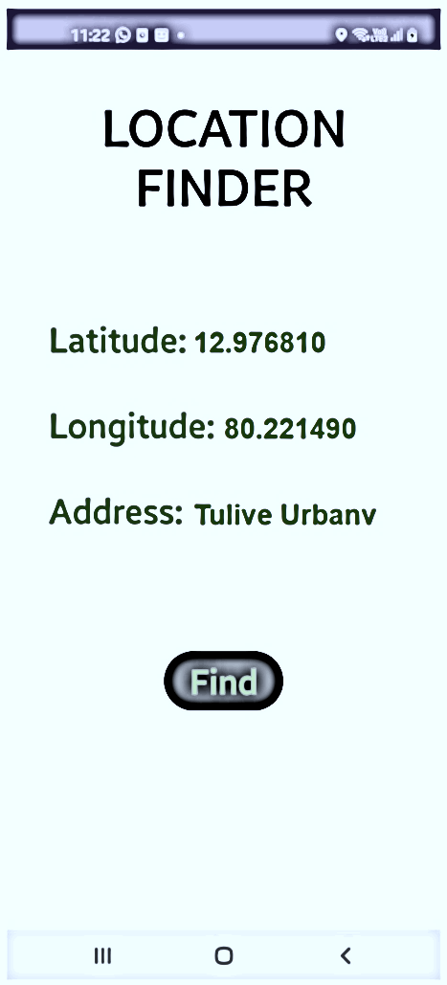

**Source code:**

* MainActivity.java

package com.example.exercise6b;

import androidx.annotation.NonNull;

import androidx.appcompat.app.AppCompatActivity;

import androidx.core.app.ActivityCompat;

import androidx.core.content.ContextCompat;

import android.Manifest;

import android.annotation.SuppressLint;

import android.content.pm.PackageManager;

import android.location.Address;

import android.location.Geocoder;

import android.location.Location;

import android.location.LocationListener;

import android.location.LocationManager;

import android.os.Bundle;

import android.view.View;

import android.widget.Button;

import android.widget.TextView;

import java.util.List;

import java.util.Locale;

public class MainActivity extends AppCompatActivity implements LocationListener {

    @Override

    protected void onCreate(Bundle savedInstanceState) {

        super.onCreate(savedInstanceState);

        setContentView(R.layout.activity_main);

        if (ContextCompat.checkSelfPermission(MainActivity.this,

                Manifest.permission.ACCESS_FINE_LOCATION) != PackageManager.PERMISSION_GRANTED) {

            ActivityCompat.requestPermissions(MainActivity.this, new String[] {

                    Manifest.permission.ACCESS_FINE_LOCATION

            }, 100);

        }

        ;

        Button find = (Button) findViewById(R.id.find);

        find.setOnClickListener(new View.OnClickListener() {

            @Override

            public void onClick(View view) {

                findLocation();

            }

        });

    }

    @SuppressLint("MissingPermission")

    private void findLocation() {

        try {

            LocationManager locationManager = (LocationManager) this.getSystemService(LOCATION_SERVICE);

            locationManager.requestLocationUpdates(LocationManager.GPS_PROVIDER, 5000, 5, MainActivity.this);

        } catch (Exception e) {

            e.printStackTrace();

        }

    }

    @Override

    public void onLocationChanged(@NonNull Location location) {

        TextView latitude = (TextView) findViewById(R.id.latitude);

        TextView longitude = (TextView) findViewById(R.id.longitude);

        try {

            Geocoder geocoder = new Geocoder(MainActivity.this, Locale.getDefault());

            TextView current_address = (TextView) findViewById(R.id.address);

            String address_name = current_address.getText().toString();

            List<Address> addresses = geocoder.getFromLocationName(address_name, 1);

            Address address_details = addresses.get(0);

            Double get_latitude = (double) Math.round(address_details.getLatitude() * 100) / 100;

            Double get_longitude = (double) Math.round(address_details.getLongitude() * 100) / 100;

            latitude.setText(String.valueOf(get_latitude));

            longitude.setText(String.valueOf(get_longitude));

        } catch (Exception e) {

            e.printStackTrace();

        }

    }

}

* activity_main.xml

<?xml version="1.0" encoding="utf-8"?>

<LinearLayout xmlns:android="http://schemas.android.com/apk/res/android"

    xmlns:app="http://schemas.android.com/apk/res-auto"

    xmlns:tools="http://schemas.android.com/tools" android:layout_width="match_parent" android:layout_height="match_parent" android:orientation="vertical" tools:context=".MainActivity">

    <TextView android:layout_width="wrap_content" android:layout_height="wrap_content" android:layout_margin="40dp" android:gravity="center|center_horizontal|center_vertical" android:layout_gravity="center|center_horizontal|center_vertical" android:text="LOCATION FINDER" android:textSize="48dp" android:typeface="monospace" android:textStyle="bold" android:textColor="#000000"/>

    <EditText android:id="@+id/address" android:layout_width="325dp" android:layout_height="50dp" android:layout_marginStart="40dp" android:layout_marginTop="30dp" android:gravity="left" android:text="Address" android:textSize="32dp" android:typeface="monospace" android:textStyle="bold" android:textColor="#55bb22"/>

    <TextView android:id="@+id/latitude" android:layout_width="wrap_content" android:layout_height="50dp" android:layout_marginStart="40dp" android:layout_marginTop="50dp" android:gravity="left" android:text="Latitude: " android:textSize="32dp" android:typeface="monospace" android:textStyle="bold" android:textColor="#55bb22"/>

    <TextView android:id="@+id/longitude" android:layout_width="wrap_content" android:layout_height="50dp" android:layout_marginStart="40dp" android:layout_marginTop="30dp" android:gravity="left" android:text="Longitude: " android:textSize="32dp" android:typeface="monospace" android:textStyle="bold" android:textColor="#55bb22"/>

    <Button android:id="@+id/find" android:layout_width="wrap_content" android:layout_height="wrap_content" android:layout_gravity="center" android:layout_marginTop="100dp" android:gravity="center" android:text="Find" android:textColor="#55bb22" android:textSize="32dp" android:textStyle="bold" android:typeface="monospace" android:backgroundTint="#000000"/>

</LinearLayout>

**Output:**

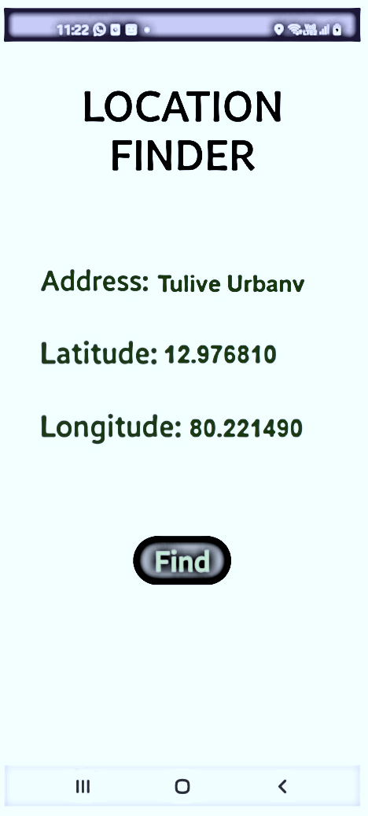

**Result:**

The mobile application was completed successfully

**Best Practices:**

1. Standard naming conventions
2. Suitable comments
3. Proper indentation
4. Proper user interface which is understandable and easy to navigate
5. Use of modularity and functions

**Learning Outcomes:**

1. Utilizing the LocationManager and LocationListener for GPS functionality in Android.
2. Requesting and handling runtime permissions for accessing device features.
3. Implementing geocoding to convert addresses into geographical coordinates.
4. Working with UI components such as TextViews, EditText, and Buttons.